# UNIT-I

**INTRODUCTION**

Digital image processing is the manipulation of digital images by mean of a computer. It has two main applications:

* Improvement of pictorial information for human interpretation
* Processing of image data for storage, transmission and representation for autonomous machine perception.

An image contains descriptive information about the object that it represents. It can be defined mathematically as a 2-dimensional function or signal f(x,y) where x and y are the spatial coordinates, and f is called the intensity or gray-level of the image at a point.

A digital image has all the three parameters x, y and f as finite and discrete quantities. It has a finite number of elements, each of which has a particular location and value. These elements are called picture elements, image elements, pels or pixels.

Humans are limited to the visual band of the Electromagnetic spectrum (EM). But, imaging machines cover almost the entire EM spectrum, ranging from gamma to radio waves. Such machines can operate on images generated by sources including ultrasound, electron microscopy and computer generated images.

Digital Image Processing encompasses processes whose inputs and outputs are images, and also the processes that extract attributes from images.

# Uses of Digital Image Processing

1. Digital Image Processing techniques are used to enhance the contrast or code the intensity levels into colors for easier interpretation of X-rays and other images used in industry, medicine, etc.
2. Geographers use similar techniques to study pollution patterns from aerial and satellite imagery.
3. Image enhancement and restoration procedures are used to process degraded images of unrecoverable objects or of experimental results that are too expensive to duplicate.
4. In archeology, Digital Image Processing techniques are used to restore blurred pictures that were the only available records of rare artifacts.
5. Applications of Digital Image Processing for machine perception include automatic character recognition, industrial machine vision for product assembly and inspection, automatic processing of fingerprints, screening of X-rays and blood samples, machine processing of aerial and satellite imagery for weather prediction and environmental assessment.

# Fundamental steps in Digital Image Processing

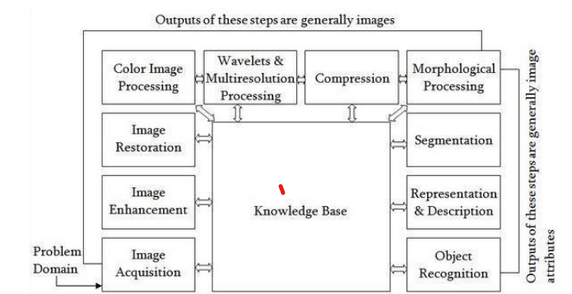

1. **Image Acquisition** . This step involves acquiring an image in digital form and preprocessing such as scaling.
2. **Image Enhancement** – it is the process of manipulating an image so that the result is more suitable than the original for a specific application. For e.g. filtering, sharpening, smoothing, etc.
3. **Image Restoration** – these techniques also deal with improving the appearance of an image. But, as opposed to image enhancement which is based on human subjective preferences regarding what constitutes a good enhancement result, image restoration is based on mathematical or probabilistic models of image degradation.
4. **Color Image Processing** – Color processing in digital domain is used as the basis for extracting features of interest in an image.
5. **Wavelets** – they are used to represent images in various degrees of resolution.
6. **Image compression** – they deal with techniques for reducing the storage required to save an image, or the bandwidth required to transmit it.
7. **Image Segmentation** – these procedures partition an image into its constituent parts or objects. This gives raw pixel data, constituting either the boundary of a region or all the points in the region itself.

# Components of an Image Processing system

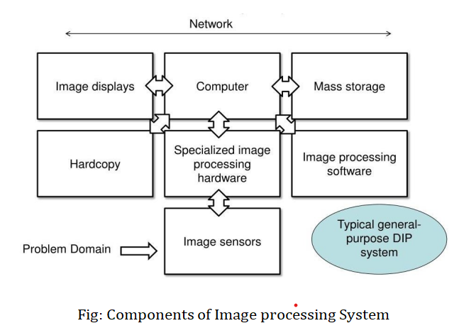

1. **Image Sensors** – two elements are required to acquire a digital image:
   1. A physical device that is sensitive to the energy radiated by the object we wish to image. And,
   2. A digitizer for converting the output of the sensor into digital form.
2. **Specialized Image Processing Hardware** – It must perform primitive operations like arithmetic and logic operations in parallel on the entire image. Its most distinguishing characteristic is speed, which the typical computer cannot perform.
3. **Computer** – This is required for primitive operations and can be a general purpose PC.
4. **Software** – it consists of specialized modules that perform specific tasks.
5. **Mass Storage** – short term storage is used during processing, online storage is used for relatively fast recall, and archival storage is used for infrequent access.
6. **Image Displays** – These are monitors used to view the result of a processing task.
7. **Networking** – It is required to transmit images.

# ELEMENTS OF VISUAL PERCEPTION

Human intuition and analysis play a central role in the choice of image processing techniques, based on subjective and visual judgments. So, it is necessary to understand how human and electronic imaging devices compare in terms of resolution and ability to adapt to changes in illumination.

# Structure of human eye

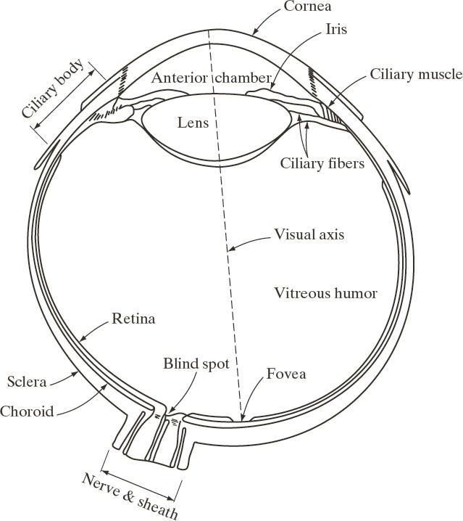

The eye is nearly a sphere, with an average diameter of approximately 20mm. three membranes enclose the eye: the **cornea and sclera** outer cover, the **choroid**, and the **retina**. The innermost membrane of the eye is the retina, which lines the inside of the wall’s entire posterior portion. When the eye is properly focused, light from an object outside the eye is imaged on the retina. Discrete light receptors are distributed over the surface of retina. They are of two types: cones and rods.

**Cones** are located primarily in the central portion of the retina, called the **fovea**. They are highly sensitive to color. Each one is connected to its own nerve end. This helps a person in resolving fine details. Muscles controlling the eye rotate the eyeball until the image of an object falls on fovea. Cone vision is called **photopic** or **bright – light vision.**

**Rods** are distributed over the retinal surface. Several rods are connected to a single nerve end. This fact along with the larger area of distribution reduce the amount of detail discernible by these receptors.

Rods give a general, overall picture of the field of view. They are not involved in color vision and are sensitive to low levels of illumination. Rod vision is called **scotopic** or **dim – light vision.**

# Image formation in the eye

In the human eye, the distance between the lens and the retina (imaging region) is fixed, as opposed to an ordinary photographic camera (where the distance between the lens and film (imaging region) is varied). The focal length needed to achieve proper focus is obtained by varying the shape of the lens, with the help of fibers in the ciliary body. The distance between the center of the lens and the retina along the visual axis is approximately 17mm, and the range of focal lengths is approximately 14mm to 17mm. The retinal image is focused primarily on the region of the fovea. Perception then takes place by

the relative excitation of light receptors, which transform radiant energy into electrical impulses that ultimately are decoded by the brain.

# Brightness adaptation and discrimination

The range of light intensity levels to which the human visual system can adapt is enormous – on the order of 1010 – from scotopic threshold to the glare limit. Subjective brightness (intensity as perceived by human visual system) is a logarithmic function of the light intensity incident on the eye.

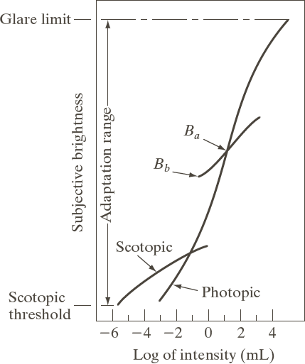

The human visual system cannot operate over the range simultaneously. Rather, it accomplishes this large variation by changing its overall sensitivity. This is known as **brightness adaptation**. The total range of distinct intensity levels the eye can discriminate simultaneously is rather small when compared with the total adaptation range. For any given set of conditions, the current sensitivity level of the visual system is called the **brightness adaptation level**. Brightness discrimination is poor at low levels of illumination, and it improves significantly as background illumination increases. At low levels of illumination, vision is carried out by the rods, whereas at high levels, vision is carried out by the cones.

# Light and Electromagnetic (EM) spectrum.

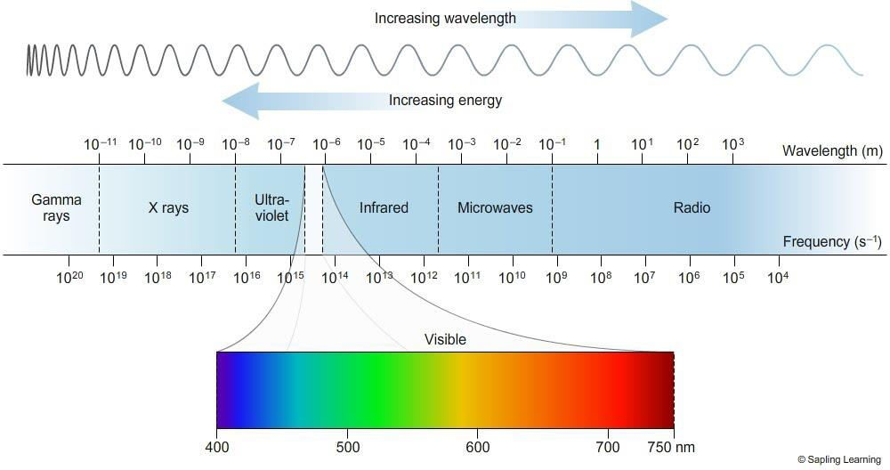

The EM spectrum ranges from gamma to radio waves. The visible part of the EM spectrum ranges from violet to red. The part of the spectrum before violet end is called Ultraviolet, and that after red end is called the Infrared.

Light that is void of color is called monochromatic or achromatic light. Its only attribute is its intensity. Intensity specifies the amount of light.

Since the intensity of monochromatic light is perceived to vary from black to gray shades and finally to white, the monochromatic intensity is called **Gray level.**

The range of measured values of monochromatic light from black to white is called the **Gray scale,** and the monochromatic images are called **gray scale images.**

Chromatic light spans the EM spectrum from 0.43μm (violet end) to 0.79μm ( red end).

The quantities that describe the quality of a chromatic light source are

1. **Frequency**
2. **Radiance** – it is the amount of energy that flows from the light source and is measured in watts.
3. **Luminance** – it is the amount of energy that an observer perceives and is measured in lumens.
4. **Brightness** – it is similar to intensity in achromatic notion, and cannot be measured.

# Image sensing and acquisition

Images are generated by the combination of an illumination source and the reflection/absorption of energy from that source by the elements of the scene being imaged. The principal sensor arrangements used to transform illumination energy into digital images are

1. Single imaging sensor
2. Line sensor
3. Array sensor

The incoming energy is transformed into a voltage by the combination of input electrical power and sensor material that is responsive to the particular type of energy being detected. The output voltage is the response of the sensors, and a digital quantity is obtained from each sensor by digitizing its response.

1. 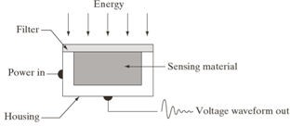**Single imageing sensor** This can be a photodiode which is constructed with silicon material and its output voltage is proportional to the amount of light falling on it. The use of filter in front of the sensor improves selectivity. For e.g. a green filter results in a stronger sensor output for green light than other components of the visible spectrum. In order to generate a 2-D image using a single imaging sensor, there has to be relative displacement in both x- and y- directions between the sensor and the area to be imaged.
2. **Line sensor** It consists of an in-line arrangement of sensors in the form of a sensor strip, which provides imaging elements in one direction. Movement perpendicular to the strip provides imaging in the other direction. This arrangement is used in most flat-bed scanners. Sensing devices with 4000 or more in-line sensors are possible. Applications of line sensors include airborne imaging of geographical areas, medical and industrial imaging to obtain 3-D images of objects, etc.



1. **Array sensor** Here the single imaging sensors are arranged in the form of a 2-D array. As the sensor array is 2-dimensional, a complete image can be obtained by focusing the energy pattern onto the surface of the array, and hence movement in any direction is not necessary. This arrangement is found in digital cameras which has CCD sensors packed in arrays of 4000 X 4000 elements or more.

# Image Acquisition

The response of each sensor is proportional to the integral of light energy projected onto the surface of the sensor. The sensor integrates this energy over minutes or hours to reduce the noise.

# Acquisition process

* The energy from an illumination source is reflected from the scene element being imaged (or the energy may be transmitted through the scene element, depending on the nature of its surface).
* The imaging system collects this reflected/transmitted energy and focuses it onto the image plane.
* The front end of the imaging system projects the viewed scene onto the lens focal plane.
* The sensor array which is coincidental with the focal plane produces outputs proportional to the integral of the light received at each sensor, which are then digitized resulting in a digital output image.

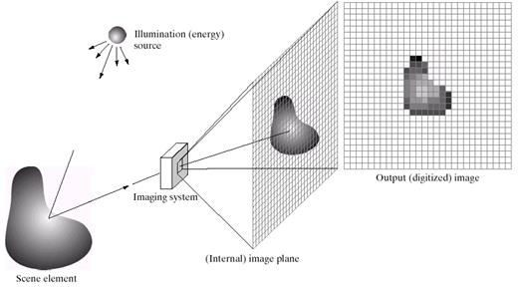

# Image Sampling and Quantization

The output of the sensors is a continuous voltage that has to be digitized. This involves two processes –

sampling and quantization.

Sampling

It is the process of digitizing the spatial coordinate values. It may be viewed as partitioning the X-Y plane into a grid of M rows and N columns with the coordinates of the center of each cell in the grid being a pair from the Cartesian product Ƶ2. So f(x,y) is a digital image if x,y ϵ Ƶ2. Each cell is called a picture element or pixel.

# Quantization

It is the process of digitizing the amplitude or intensity values.

Let f(s,t) represent a continuous image function of two continuous variables s and t. to convert it to a digital image,

1. **Sampling** – we sample the continuous image into a 2-D array f(x,y) containing M rows and N columns, where (x,y) are discrete coordinates taking up integer values x=0, 1, ……, M-1 and y=0,1,….., N-1. So f(0,1) indicates the second sample along the first row. Here, 0 and 1 are not the values of physical coordinates when the image was sampled.
2. **Quantization –** the values of the above samples that span a continuous range of intensity values, must be converted to discrete quantities. This is done by dividing the entire continuous intensity scale into L discrete intervals, ranging from black to white, where black is represented by a value 0 and white by L-1. Depending on the proximity of a sample to one of these L levels, the continuous intensity levels are quantized. In addition to the number of discrete levels used, the accuracy achieved in quantization is highly dependent on the noise content of the sampled signal.

The digitization process requires that decisions be made regarding values for M, N and L. M and N must only be positive integers. Due to internal storage and quantizing hardware considerations, the number of intensity levels typically is an integer power of 2 .i.e., L = 2K, and the image is referred to as a K-bit image. For e.g. an image with 256 intensity levels is called an 8-bit image. The number of bits required to store a digitized k-bit image is b=MNK.

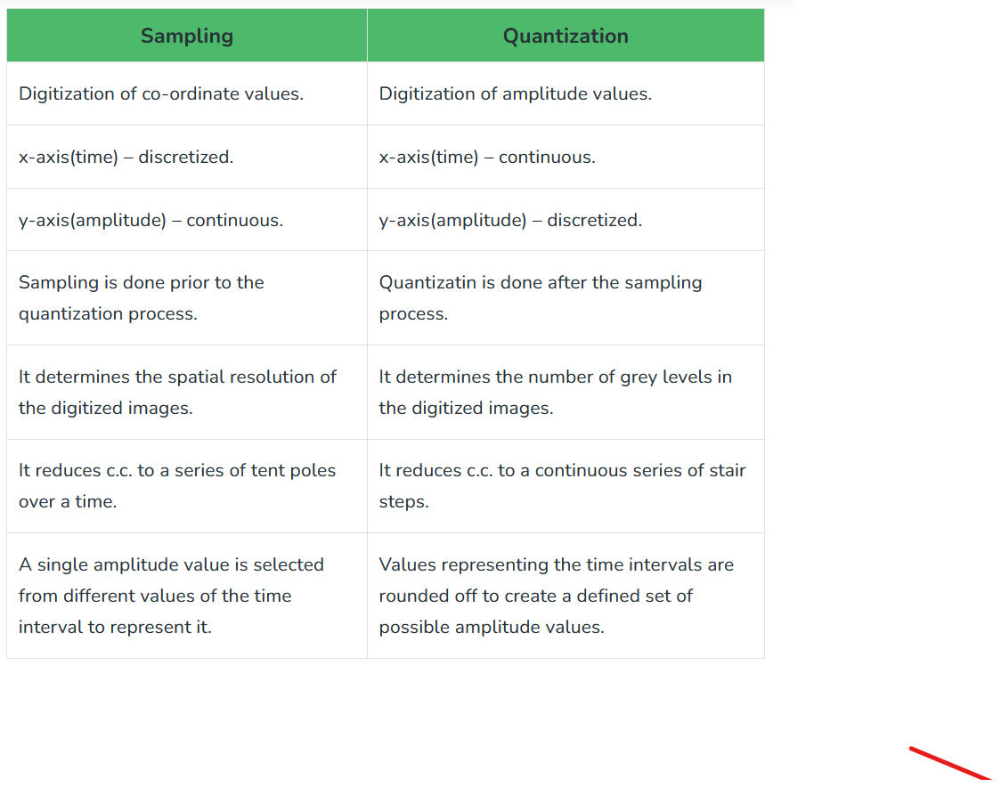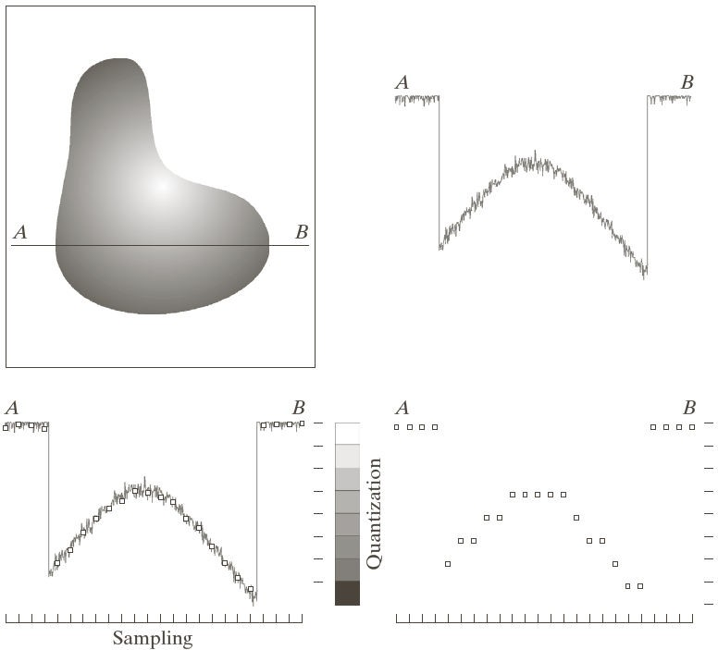

# 

# Digital Image Fundamentals

* 1. **Dynamic Range** - It is the ratio of maximum measurable intensity to the minimum detectable intensity level in the imaging system. It establishes the lowest and highest intensity levels that an image can have.
     + The upper limit is determined by **Saturation.** It is the highest value beyond which all intensity levels are clipped. In an image, the entire saturated area has a high constant intensity level.
     + The lower limit is determined by **noise.** Especially in the darker regions of an image, the noise masks the lowest detectable true intensity level.
  2. **Contrast** – It is the difference in intensity between the highest and lowest intensity levels in an image. For example, a low contrast image would have a dull washed out gray look.
  3. **Spatial resolution** – it is a measure of the smallest detectable detail in an image. It is measured as line pairs per unit distance, or dots or pixels per unit distance (Dots per Inch or DPI). For example, newspapers are printed with a resolution of 75DPI, whereas textbooks are printed with a resolution of 2400 DPI.
  4. **Intensity Resolution** – It is a measure of the smallest detectable change in intensity level. It refers to the number of bits used to quantize intensity. For example, an image whose intensity is quantized into 256 levels is said to have 8-bits of intensity resolution.

# Relationship between Pixels:

We consider several important relationships between pixels in a digital image.

# Neighbors of a Pixel:

A pixel *p* at coordinates (*x*,*y*) has four horizontal and verticalneighbors whose coordinates are givenby:

(x+1,y), (x-1, y), (x, y+1), (x,y-1)

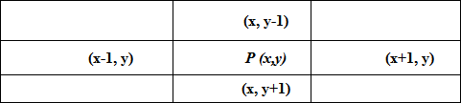

This set of pixels, called the 4-neighbors or p, is denoted by N4(p). Each

pixel is one unit distance from (x,y) and some of the neighbors of p lie outside the digital image if (x,y) is on the border of the image. The four diagonal neighbors of p have coordinates and are denoted by ND(p).

(x+1, y+1), (x+1, y-1), (x-1, y+1), (x-1, y-1).

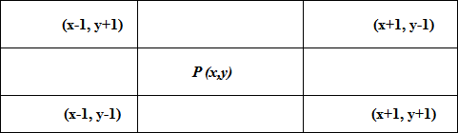

These points, together with the 4-neighbors, are called the 8-neighbors of p, denoted by N8(p).

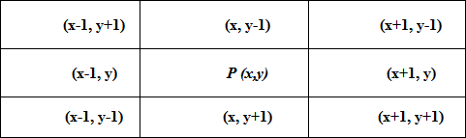

As before, some of the points in ND(p) and N8(p) fall outside the image if (x,y) is on the border of the image.

1. **Adjacency** – let V be the set of intensity values used to define adjacency. For example, if we consider a binary image which has only two intensity values : 0 (representing black) and 1 (representing white), then V can be chosen as V = {1}.

Let V={1} for the following definitions. Consider the following arrangement of pixels (binary image).

|  |  |  |  |  |
| --- | --- | --- | --- | --- |
| 0 | 0 | 0 | 0 | 0 |
| 0 | 0 | 1(B) | 1(C) | 0 |
| 1(D) | 0 | 1(A) | 0 | 0 |
| 1(E) | 0 | 0 | 0 | 0 |
| 0 | 1(F) | 1(G) | 0 | 0 |

* **4-Adjacency** – two pixels p and q with values from set V are said to be **4-adjacent** if q is in set N4(p). For example, in the adjoining figure, A and B are **4-adjacent**, since they are 4-neighbors of each other. But, A and C are not 4-adjaacent.
* **8-adjacency** - Two pixels p and q with values from set V are **8-adjacent** if q is in N8(p).i.e., if p and q are either horizontal, vertical or diagonal neighbors. For example, in the above figure, (A and B), (A and C) and (B and C) are 8-adjacent.
* **m**-**adjacency** – Two pixels p and q with intensity values from V are **m-adjacent** if either of the following two conditions are satisfied:
  + q is in N4(p), or
  + q is in ND(p), and the set N4(p) ∩ N4(q) has no pixels with values from V.

For example, in the above figure, (A and B), (B and C), (D and E) and (F and G) are m-adjacent since they satisfy the first condition. (E and F) are also m-adjacent since they satisfy the second condition, although they violate the first condition. (A and C) are not m-adjacent since they violate both conditions.

1. **Path** - a path from pixel p with coordinates (x,y) to pixel q with coordinates (s,t) is a sequence of distinct pixels with coordinates (x0, y0), (x1, y1), … (xn, yn) where pixels (xi , yi) and (xi-1 , yi-1) are

adjacent for 1≤ i ≤ n, and where (x0, y0) =(x,y) and (xn , yn) = (s,t).

* + Here, n is the **length of the path.**
  + If (x0 , y0) and (xn , yn) are the same, then the path is a **closed path.**
  + Depending on the type of adjacency, we can have **4-path, 8-path** or **m-path.**

|  |  |  |
| --- | --- | --- |
| 0 | 1(A) | 1(B) |
| 0 | 1(C) | 0 |
| 0 | 0 | 1(D) |

For example, in the above arrangement of pixels, the paths are as follows:

**4-path** : B A C

**8-paths**: (i) B A C, (ii) B A C D, (iii)B C D

**m**-**path**: B A C D

1. **Connectivity** – let S represent a subset of pixels in an image. Then, two pixels p and q are said to be **connected** in S, if there exists a path between them consisting entirely of pixels in S. For example, in the previous figure, if all the 9 pixels form the subset S, then B and C (or B and D in case of 8 and m-paths) are said to be connected to each other. On the other hand, if S consists of pixels of rightmost column, then B and D are not connected to each other.

* For any pixel p in S, the set of pixels that are connected to it in S is called a **connected component** of S. for example, if all the 9 pixels in the above figure form S, the pixels A, B, C and D form a connected component.
* If the subset S has only one connected component, then the set S is called a **connected set.** For example,

1. The following is a connected set

|  |  |  |  |  |
| --- | --- | --- | --- | --- |
| 0 | 0 | 0 | 0 | 0 |
| 0 | 0 | 1 | 1 | 0 |
| 0 | 0 | 1 | 0 | 0 |
| 0 | 0 | 0 | 1 | 0 |
| 0 | 0 | 0 | 0 | 0 |

1. The following subset is not a connected set, since it has two connected components.

|  |  |  |  |  |
| --- | --- | --- | --- | --- |
| 0 | 0 | 0 | 0 | 0 |
| 0 | 0 | 1 | 1 | 0 |
| 0 | 0 | 1 | 0 | 0 |
| 0 | 0 | 0 | 1 | 0 |
| 0 | 0 | 0 | 0 | 0 |
| 0 | 0 | 1 | 1 | 0 |
| 0 | 0 | 0 | 1 | 0 |
| 0 | 0 | 0 | 0 | 0 |

1. **Region** – let R be a subset of pixels of an image. R is called a region of the image, if R is a connected set.
   * Two regions Ri and Rj are said to be **adjacent** if their union forms a connected set. Regions that are not adjacent are said to be **disjoint**. We consider 4 and 8-adjacency only when referring to regions. For example, considering two regions Ri and Rj as follows:

|  |  |  |
| --- | --- | --- |
| 1 | 1 | 1 |
| 1 | 0 | 1 |
| 0 | 1(A) | 0 |
| 0 | 0 | 1(B) |
| 1 | 1 | 1 |
| 1 | 1 | 1 |

Ri

Rj

Pixels A and B are 8-adjacent but not 4-adjacent. Union of Ri and Rj will form a connected set if 8- adjacency is used, and then Ri and Rj will be **adjacent regions**. If 4-adjacency is used, they will be **disjoint regions.**

1. **Boundary** – let an image contain K disjoint regions. Let RU denote the pixels in the connected components of the union of all these K regions, and let R C denote its complement. Then R is called the **foreground** and R C is called the **background** of the image. The **inner border/boundary** of a region R is the set of pixels in the region that have atleast one background neighbor (adjacency must be specified).

U

U U

1. **Distance Measures** – consider pixels p and q with coordinates (x,y) and (s,t) respectively.
   * **Euclidean distance** – it is defined as 𝐷𝑒(𝑝, 𝑞) = √[(𝑥 − 𝑠)2 + (𝑦 − 𝑡)2]. All the pixels that have Euclidean distance less than or equal to a value r from pixel p(x,y) are contained in a disk of radius r centered at (x,y).
   * **D4 distance (City-block distance)** – it is defined as 𝐷4(𝑝, 𝑞) = |𝑥 − 𝑠| + |𝑦 − 𝑡|. All the pixels having D4 distance less than or equal to a value r are contained in a diamond centered at (x,y). Also, all the pixels with D4 =1 are the 4-neighbors of (x,y).
   * **D8 distance ( Chessboard distance)** – it is defined as 𝐷8(𝑝, 𝑞) = 𝑚𝑎𝑥(|𝑥 − 𝑠| , |𝑦 − 𝑡|). All the pixels with D8 distance less than or equal to some value r from (x,y) are contained in a square centered at (x,y). All pixels with D8 =1 are the 8-neigbors of (x,y).
   * De , D4 and D8 distances are independent of any paths that may exist between p and q.
   * **Dm distance** – it is defined as the shortest m-path between p and q. So, the Dm distance between two pixels will depend on the values of the pixels along the path, as well as on the values of their neighbors. For example, consider the following subset of pixels

|  |  |  |
| --- | --- | --- |
| P8 | P3 | P4 |
| P1 | P2 | P6 |
| P | P5 | P7 |

For adjacency, let V={1}. Let P, P2 and P4 =1

1. If P1, P3, P5, P6, P7, and P8 = 0. Then the Dm distance between P and P4 is 2 (only one m-path exists: P – P2 – P4)

|  |  |  |
| --- | --- | --- |
| 0 | 0 | 1 |
| 0 | 1 | 0 |
| 1 | 0 | 0 |

1. If P, P1 , P2 and P4 =1, and rest are zero, then the Dm distance is 3 (P – P1 –

P2 – P4)

|  |  |  |
| --- | --- | --- |
| 0 | 0 | 1 |
| 1 | 1 | 0 |
| 1 | 0 | 0 |

# Mathematical Tools used in Digital Image Processing

1. **Array versus Matrix operations** – Array operations in images are carried out on a pixel – by – pixel basis. For example, raising an image to a power means that each individual pixel is raised to that power. There are also situations in which operations between images are carried out using matrix theory.
2. **Linear versus Nonlinear operations** – considering a general operator H that when applied on an input image f(x,y) gives an output image g(x,y) .i.e.,

𝐻[ƒ(𝑥, 𝑦)] = 𝑔(𝑥, 𝑦)

Then, H is said to be a linear operator if

𝐻[𝑎ƒ1(𝑥, 𝑦) + 𝑏ƒ2(𝑥, 𝑦)] = 𝑎𝑔1(𝑥, 𝑦) + 𝑏𝑔2(𝑥, 𝑦)

Where, a and b are arbitrary constants. f1(x,y) and f2(x,y) are input images, and g1(x,y) and g2(x,y) are the corresponding output images.

That is, if H satisfies the properties of additivity and homogeneity, then it is a **linear operator**.

1. **Arithmetic operations** – these operations are array operations and are denoted by

S(x,y) = f(x,y) + g(x,y)

D(x,y) = f(x,y) – g(x,y)

P(x,y) = f(x,y) * g(x,y)

V(x,y) = f(x,y) ÷ g(x,y)

These operations are performed between corresponding pixel pairs in f and g for x = 0, 1, 2, …

M-1 and y = 0, 1, 2, …, N-1, where all the images are of size M X N. For example,

* if we consider a set of K noisy images of a particular scene {gi(x,y)}, then, in order to obtain an image with less noise, averaging operation can be done as follows:

1 𝐾

𝑔̅(𝑥, 𝑦) = 𝐾 ∑ 𝑔i(𝑥, 𝑦)

i=1

This averaging operation can be used in the field of astronomy where imaging under very low light levels frequently causes sensor noise to render single images virtually useless for analysis.

* **Image Subtraction** – this operation can be used to find small minute differences between images that are indistinguishable to the naked eye.
* **Image Multiplication** – this operation can be used in masking where some regions of interest need to be extracted from a given image. The process consists of multiplying a given image with a mask image that has 1s in the region of interest and 0s elsewhere.
* In practice, for an n-bit image, the intensities are in the range [0 , K] where K = 2n – 1. When arithmetic operations are performed on an image, the intensities may go out of this range. For example, image subtraction may lead to images with intensities in the range [ - 255 , 255]. In order to bring this to the original range [0, K], the following two operations can be performed. If f(x,y) is the result of the arithmetic operation, then
  + We perform ƒ𝑚(𝑥, 𝑦) = ƒ(𝑥, 𝑦) − 𝑚i𝑛[ƒ(𝑥, 𝑦)]. This creates an image whose minimum value is zero.
  + Then, we perform

ƒ (𝑥, 𝑦) = 𝐾 [ ƒ𝑚(𝑥, 𝑦) ]

𝑠 𝑚𝑎𝑥[ƒ𝑚(𝑥, 𝑦)]

This results in an image fS (x,y) whose intensities are in the range [ 0 , K ].

* While performing image division, a small number must be added to the pixels of divisor image to avoid division by zero.

1. **Set Operations** – for gray scale images, set operations are array operations. The **union** and **intersection** operations between two images are defined as the maximum and minimum of corresponding pixel pairs respectively. The **complement** operation on an image is defined as the pairwise differences between a constant and the intensity of every pixel in the image.

Let set A represent a gray scale image whose elements are the triplets (x, y, z) where (x,y) is the location of the pixel and z is its intensity. Then,

**Union** : **Intersectin Complemet:**

𝐴 𝖴 𝐵 = {max(𝑎, 𝑏)|𝑎 ∈ 𝐴, 𝑏 ∈ 𝐵}

𝑧

𝐴 ∩ 𝐵 = {min(𝑎, 𝑏)|𝑎 ∈ 𝐴, 𝑏 ∈ 𝐵}

𝑧

𝐴𝐶 = {(𝑥, 𝑦, 𝐾 − 𝑧)|(𝑥, 𝑦, 𝑧) ∈ 𝐴}

1. **Logical Operations** – when dealing with binary images, the 1 – valued pixels can be thought of as foreground and 0 – valued pixels as background. Now, considering two regions A and B composed of foreground pixels,

The **OR** operation of these two sets is the set of coordinates belonging either to A or to B or to both.

The **AND** operation is the set of elements that are common to both A and B. The **NOT** operation on set A is the set of elements not in A.

The logical operations are performed on two regions of same image, which can be irregular and of different sizes.

The set operations involve complete images.

[Basics of OpenCV](https://www.geeksforgeeks.org/set-opencv-anaconda-environment/)

In this we’ll try to open an image by using OpenCV (Open Source Computer Vision) library.  Following types of files are supported in OpenCV library:

* Windows bitmaps – *.bmp, *.dib
* JPEG files – *.jpeg, *.jpg
* Portable Network Graphics – *.png
* WebP – *.webp
* Sun rasters – *.sr, *.ras
* TIFF files – *.tiff, *.tif
* Raster and Vector geospatial data supported by GDAL

  To use the OpenCV library in python, we need to install these libraries as a prerequisite:

1. Numpy Library : The computer processes images in the form of a matrix for which NumPy is used and  OpenCV uses it in the background.
2. OpenCV python : OpenCV library previously it was cv but the updated version is cv2. It is used to manipulate images and videos.

**To install these libraries, we need to run these pip commands in cmd:**

pip install opencv-python

pip install numpy

pip install matplotlib

**The steps to read and display an image in OpenCV are:**

1. Read an image using imread() function.

2. Create a GUI window and display image using imshow() function.

3. Use function waitkey(0) to hold the image window on the screen by the specified number of seconds, o means till the user closes it, it will hold GUI window on the screen.

4. Delete image window from the memory after displaying using destroyAllWindows() function.

Let’s start reading an image. using cv2.  
 To read the images cv2.imread() method is used. This method loads an image from the specified file. If the image cannot be read (because of missing file, improper permissions, unsupported or invalid format) then this method returns an empty matrix.

**Syntax:** cv2.imread(path, flag)

**Parameters:**  
**path:** A string representing the path of the image to be read.  
**flag:** It specifies the way in which image should be read. It’s default value is **cv2.IMREAD_COLOR**

**Return Value:** This method returns an image that is loaded from the specified file.

**Note:**

1. The image should be in the working directory or a full path of image should be given.
2. By default, OpenCV stores colored images in BGR(Blue Green and Red) format.

All three types of flags are described below:

**cv2.IMREAD_COLOR:** It specifies to load a color image. Any transparency of image will be neglected. It is the default flag. Alternatively, we can pass integer value **1** for this flag.  
**cv2.IMREAD_GRAYSCALE:** It specifies to load an image in grayscale mode. Alternatively, we can pass integer value **0** for this flag.  
**cv2.IMREAD_UNCHANGED:** It specifies to load an image as such including alpha channel. Alternatively, we can pass integer value **-1** for this flag.

# IMAGE TRANSFORMS

**Need for Transforms**

Transform is the process of representing data in a different domain that is different from the raw domain. This is done because some image processing tasks are best formulated by transforming the input images, carrying the specified task in the transform domain, and applying the inverse transform to return back to spatial domain. If 𝑥̅ is an N – by – 1 vector and 𝑇̅ is an N – by – N matrix, then 𝑦̅ = 𝑇̅𝑥̅ is a linear transformation of vector 𝑥̅. It is called **forward** **transformation**. 𝑇̅ is called the **kernel** **matrix.** The **inverse** **transformation** is given by 𝑥̅ = 𝑇̅−1𝑦̅. To make the transformation invertible, 𝑇̅ must be non – singular.

The inner product of any row of 𝑇̅ with itself is 1, and with any other row it is 0. So, the rows of 𝑇̅ are a set of orthonormal vectors, and form an orthonormal basis for the N – dimensional vector space of all N

– by – 1 vectors.

The **forward transformation** is the process of **analysis**, breaking the signal vector down into its elemental components.

The **inverse transformation** is the process of **synthesis,** reassembling the original vector from its components.

The discrete image transforms are classified into three categories:

1. **Sinusoidal Transforms** – they use sinusoidal basis functions. For example, Discrete Sine Transform (DST), Discrete Cosine Transform (DCT), Discrete Fourier Transform (DFT), etc.
2. **Rectangular wave Transforms** – They use basis functions that are variations of a square wave. They are fast to compute since many of the multiplications become trivial. For example, Haar, Walsh, Hadamard transforms, etc.
3. **Eigenvector based transforms** – they use basis functions that are derived from eigenanalysis. For example, KL transform, Singular Value Decomposition, etc.

# Sinusoidal Transforms

* 1. **Discrete Fourier Transform**

**Fourier Transform** is an important image processing tool which is used to decompose an image into its frequency components. It serves as an important tool in image analysis, image filtering, image reconstruction, image compression, etc. the 2-dimensional Fourier Transform of an image f (s,t) is given by

∞ ∞

𝐹(𝛼, 𝛽) = ∫ ∫ ƒ(𝑠, 𝑡)e−j(𝛼𝑠+𝛽𝑡)𝑑𝑠𝑑𝑡

−∞ −∞

Where 𝛼 𝑎𝑛𝑑 𝛽 are called the **spatial frequencies**.

For digital images, we consider the 2 – D DFT. This DFT is the sampled version of the previous equation. So, the 2 – D DFT does not contain all the frequencies forming the image. The image in the spatial and frequency domain are of the same size.

if f (x,y) is an M X N digital image, then its 2-D DFT F (u,v) is given by

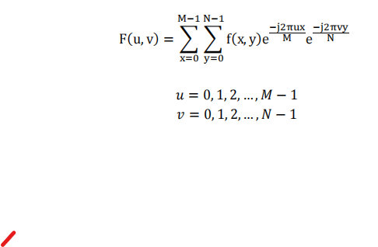

Each point in the DFT gives the value of the image at a particular frequency. For example, F(0 , 0) represents the DC – component of the image and gives the average brightness of the image. Similarly, F(N-1 , N-1) represents the highest frequency (sharp edges).

Since F(u , v) is seperable, it can be written as

where

𝑁−1

𝐹(𝑢, 𝑣) = ∑ 𝑃(𝑢, 𝑦)e−j2𝜋𝑣𝑦/𝑁

𝑦=0

𝑁−1

𝑃(𝑢, 𝑦) = ∑ ƒ(𝑥, 𝑦)e−j2𝜋𝑢𝑥/𝑁

𝑥=0

So, the 2 – D DFT of an image can be obtained by first applying the second equation above on the image, which is applying a 1 – Dimensional N – point DFT on the rows of the image to get an intermediate image. Then the first equation above is applied on the intermediate image, which is applying 1- D DFT on the columns of the intermediate image.

Applying a 1 – D DFT has N2 complexity. This can be reduced to 𝑁 log2 𝑁 using the Fast Fourier Transform.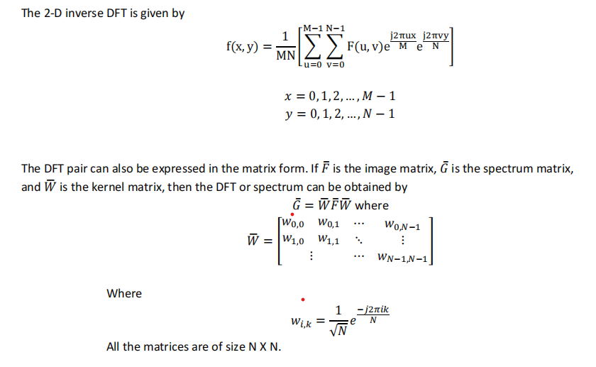

# Properties of 2-D DFT

1. **Relation between spatial intervals and frequency intervals**

In 1-dimension, if f(n) consists of M samples of a function f(t) taken ΔT units apart (sampling

period), then

ƒ(𝑛) = ƒ(𝑡)𝑎𝑡 𝑡 = 𝑛∆𝑇

Then, its 1-D Discrete Fourier Transform is given by

𝐹(𝑘) = ∑ ƒ(𝑛)e−j2𝜋𝑛k/𝑁

And its Discrete Time Fourier Transform (DTFT) is given by

𝐹(ej𝜔) = ∑ ƒ(𝑛)e−j𝜔𝑛∆𝑇 = ∑ ƒ(𝑛)e−j2𝜋𝑢𝑛∆𝑇

u =cyclic frequency

2𝜋k k

to convert DTFT to DFT, we discretize in ω at 𝜔 = 𝑁∆𝑇 or at 𝑢 = 𝑁∆𝑇 (∵ 𝜔 = 2𝜋𝑢)

from above, it can be found that the spacing between the frequencies is

∆𝑢 = 1

𝑁∆𝑇

In 2-D case, f(t,z) is a continuous image which is sampled to obtain digital image f(x,y) consisting of M samples in t-direction and N samples in z-direction. Let ΔT and ΔZ be the spatial intervals in t and z- directions. Then, the frequency intervals are given by

∆𝑢 = 1

𝑀∆𝑇

, ∆𝑣 = 1

𝑁∆𝑍

The frequency spacing is inversely proportional to both the spatial spacing and to the number of samples in that direction.

# Translation property

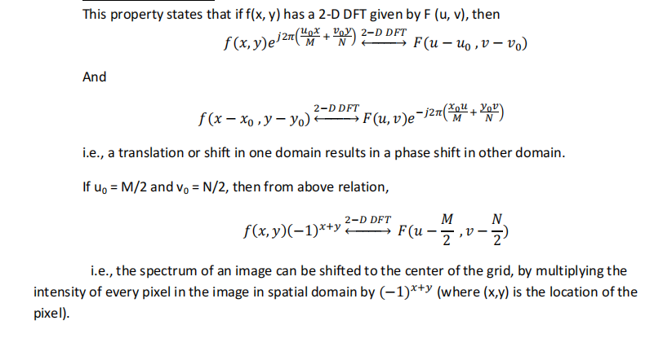

# Rotation Property

This property can be obtained by expressing the independent variables in polar form instead of Cartesian coordinates, as follows:

Spatial coordinates: x=rcosθ , y=rsinθ

Frequency variables: u=ωcosφ , v= ωsinφ

Image in spatial domain in polar form : f(r, θ)

Image in transform domain (DFT of the image) in polar form : F(ω , φ) Then, it can be shown that the 2-D DFT relation can be expressed as

M−1 N−1

F(ω, ∅) = ∑ ∑ f(r, θ)e

M

x=0 y=0

−j2πωrcos(θ−∅)

Now, according to rotation property, if the image is rotated by an angle θ0, its DFT (in polar form) is given by

2−𝐷 𝐷𝐹𝑇

ƒ(𝑟, 𝜃 + 𝜃0) ↔− − → 𝐹(𝜔, ∅ + 𝜃0)

# Periodicity

This property states that the 2-D DFT is periodic in both variables u and v, with period M or N or both. i.e.,

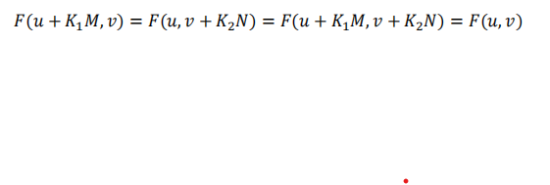

# Symmetry Properties

Any image f(x,y) can be expressed as a sum of an even and an odd function as follows

ƒ(𝑥, 𝑦) = ƒ𝑒(𝑥, 𝑦) + ƒo(𝑥, 𝑦)

Where

ƒ (𝑥, 𝑦) ≜ ƒ(𝑥, 𝑦) + ƒ(−𝑥, −𝑦)

𝑒 2

ƒ (𝑥, 𝑦) ≜ ƒ(𝑥, 𝑦) − ƒ(−𝑥, −𝑦)

o 2

Even function is a symmetric function .i.e., ƒ𝑒(𝑥, 𝑦) = ƒ𝑒(−𝑥, −𝑦)

And, odd function is antisymmetric .i.e., ƒo(𝑥, 𝑦) = −ƒo(−𝑥, −𝑦)

Since all the indices in the DFT or IDFT are positive, the symmetry or antisymmetry is defined about the center point of the sequence. The indices to the right of center are considered positive, and those to the left are considered negative. So, the even and odd functions are redefined as follows:

Even function : ƒ𝑒(𝑥, 𝑦) = ƒ𝑒(𝑀 − 𝑥, 𝑁 − 𝑦)

And, odd function : ƒo(𝑥, 𝑦) = −ƒo(𝑀 − 𝑥, 𝑁 − 𝑦)

# 

